Lecture notes

# Intro

General trends in internal migration (IMAGE):

* Decline of overall intensity
* Reurbanisation
* (Education expansion (?))

# Aim

To gain a comprehensive picture of internal migration in Austria along the urban-rural gradient.

* Intensities & spatial patterns
* Changes over time

**HOW?**Applying different definitions of urban (for now OECD/EU & Statistik Austria)

# Definition

**What is urban?**

*Urban Dilemma… already stressed by Darren Hossack / ABS (comparing OECD and local definitions for Australian urban areas)… in yesterdays presentation*

Example of Vienna:

**OECD** definition (based on NUTS3 typology)  
3 types: predominately urban – intermediate – predominately rural

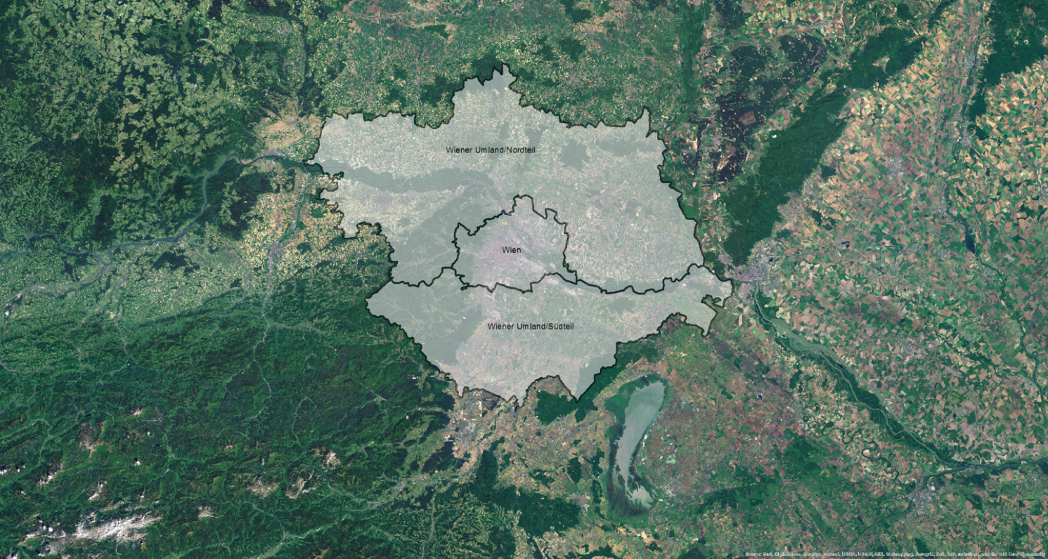

Statistik Austria definition (based on municipalities), based on:

* density / continuous build-up area
* commuter (share of commuters to urban core)

3 types: urban cores – outer zones – non-urban/rural

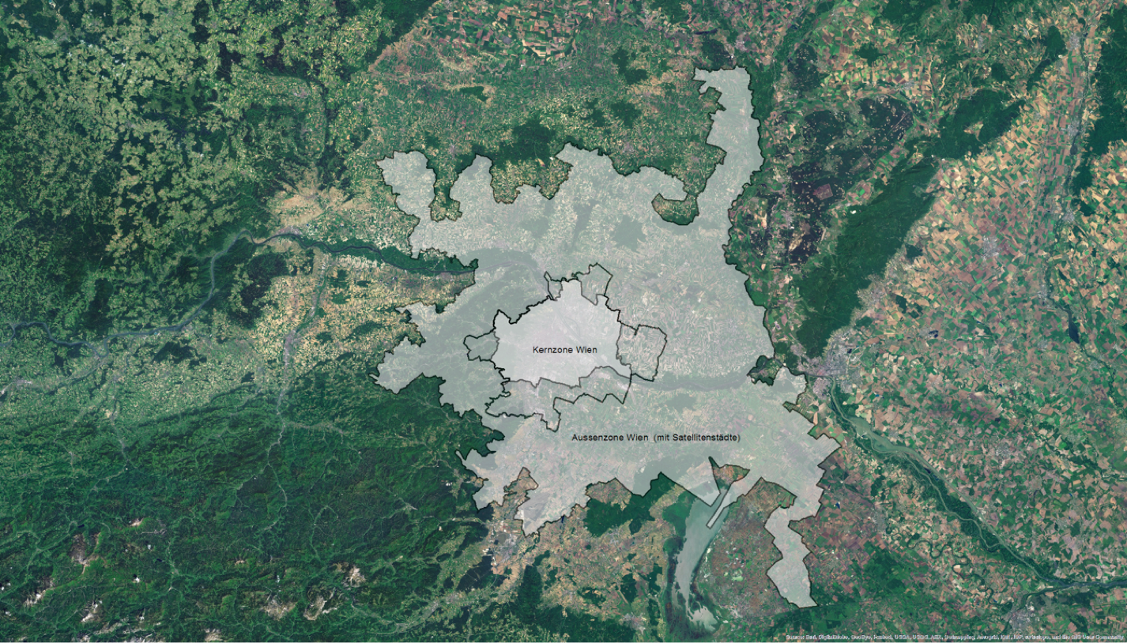

# Data

Austria

* Spatial: Municipalities
* Temporal: 1996-2013 (annual data)
* Population: by age & sex   
  (analysis) both sexes by 7 age groups:   
  less than 18 years, 18-24, 25-29, 30-34, 35-49, 50-64, 65+

Register-based data since 2002 (break in series):

* Data quality improved since 2002 🡪 focus on 2002-2013

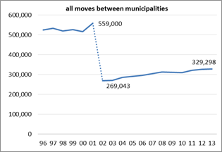

**Custom geographies**   
based on municipalities –– allow … **to explore the impact of different geographies on internal flows along the urban-rural gradient.**

# Trends & Patterns

(2002 / 2013)

LINE CHARTS (based on Statistik Austria definition)

**Trends**

ALL AGES

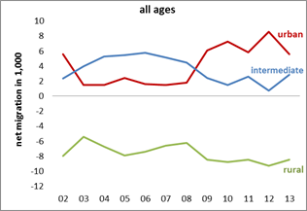

(positive)

urban core  
outer zones

(negative)

rural

….

trend driven (to large extent) by 18-24 years

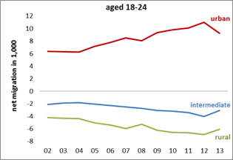

… (almost linear) trend towards urban cores

(negative) outer zones & rural

**Spatial Patterns**

Are all city regions gaining (universally)? Example of **1824**   
… change classification from **minus 9 to plus 9**

**2002**

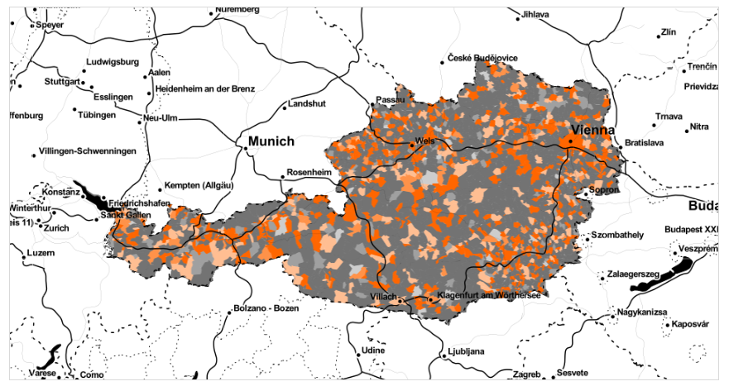

**2013**… more spatially focused on urban cores (increasing attractiveness of cities)

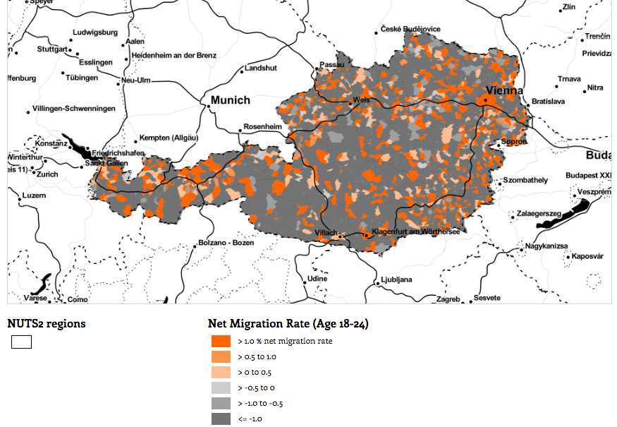

all municipalities 🡪 **need to reduce complexity**highlighting 2 custom geographies (based on municipalities)

**NUTS3 (OECD typology)**

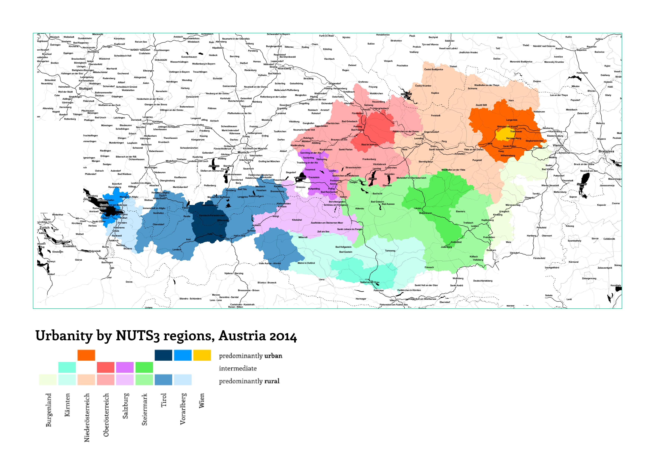

**CITY Regions (according to Statistik Austria)**

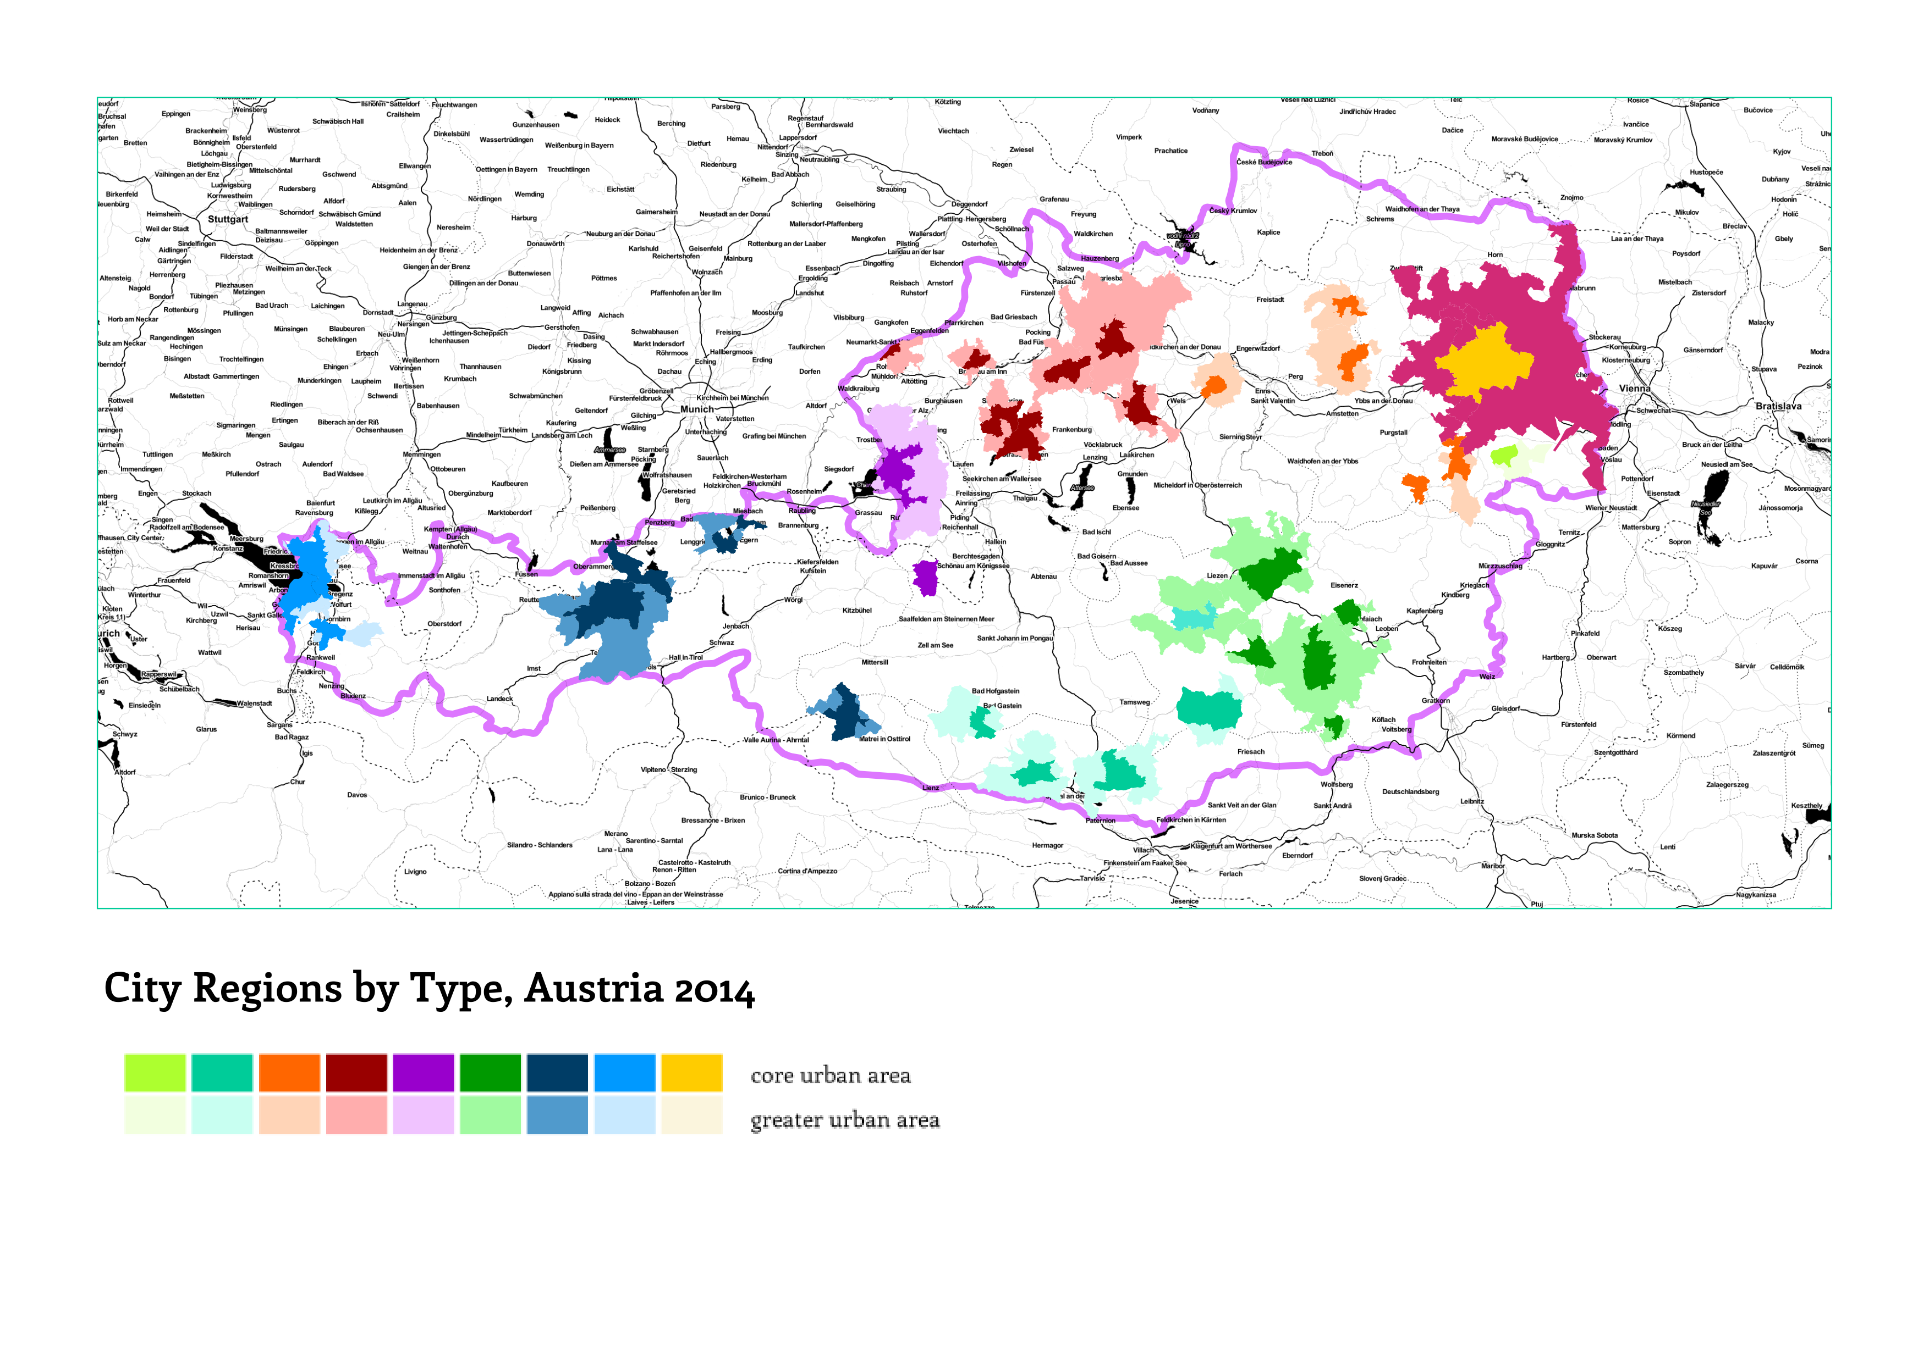

**PLOTS**

NUTS3

2002 > 2013

2013

* more interregional movements  
  more within NUTS3, less between (compared to 2002)
* Vienna … volume has increased (plot segment shows volume)

Example of Styria / Graz region   
(2nd largest city; most dynamic urban region in AT during last decade)

* More movement to intermediate

Graz N3 region intermediate???  
(ironic) N3 does not work (in the case of Austria)

CITY REGIONS

Works better (core / outer zones / rural)

SHOW / stress **🡪 Urban Hierarchy (18-24)**

* Smaller city cores WIN … from outer zones & rural
* (smaller cores) lose … to Vienna & Graz (core)

“stepwise “ (= NEW)

NUTS3 … intra-regional ???

2013 (compared to 2002)

* Stronger intra-core flows

# Conclusions

Overall increase in volume of movements

Growing attractiveness of core cities for 18-24 age group

Intra-city movements, esp to largest cities (Vienna and Graz)

Continued family migration to outer urban zones

Next steps:

* alternative geographies,   
  e.g.: by density, or different national classifications  
    
  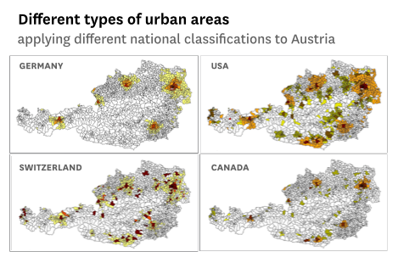
* closer look at different age groups
* cross-national comparisons (AT – DE)
* interactive visualisations for public & policy